Physiotherapy referral form
(To be completed by GP)
Patient name: |  |  | DOB:
Address:
Contact No: | (home) (mobile)
GP name:
GP Practice:
Reason for referral: | 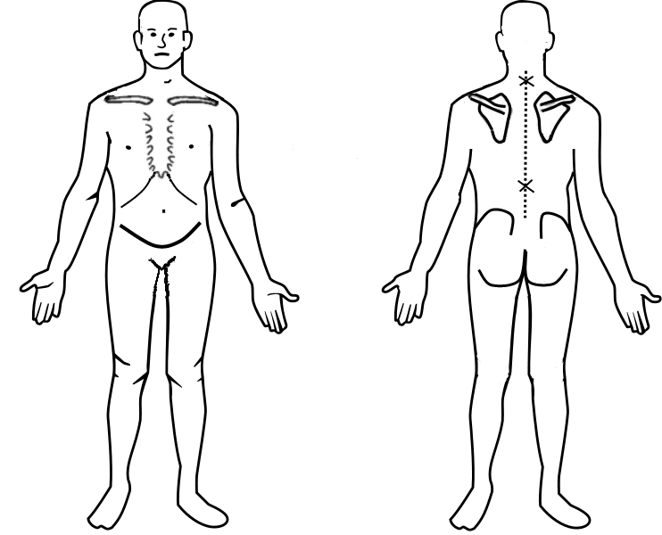
GP Signature: |  | Date:
Please return to: The Physiotherapy Centre, Holy Cross Hospital, Haslemere, GU27 1NQ
Email: therapy@holycross.org.uk
Telephone: 01428 647647
Fax: 01428 644007
Upon receipt of this referral, a physiotherapist will assess the referred patient, and discuss suitable treatment options with them.

